**ASSIGNMENT 2 FRONT SHEET**

|  |  |  |  |
| --- | --- | --- | --- |
| **Qualification** | **BTEC Level 5 HND Diploma in Computing** | | |
| **Unit number and title** | PROG102: Procedural Programming | | |
| **Submission date** |  | **Date Received 1st submission** |  |
| **Re-submission Date** |  | **Date Received 2nd submission** |  |
| **Student Name** | Bùi Hương Linh | **Student ID** | GBH200662 |
| **Class** | GCH1002 | **Assessor name** | Đỗ Tiến Thành |
| **Student declaration**  I certify that the assignment submission is entirely my own work and I fully understand the consequences of plagiarism. I understand that making a false declaration is a form of malpractice. | | | |
|  |  | **Student’s signature** |  |

**Grading grid**

|  |  |  |  |  |
| --- | --- | --- | --- | --- |
| P4 | P5 | M3 | M4 | D2 |
|  |  |  |  |  |

|  |  |  |
| --- | --- | --- |
| **❒ Summative Feedback:                                                                 ❒ Resubmission Feedback:** | | |
| **Grade:** | **Assessor Signature:** | **Date:** |
| **Lecturer Signature:** | | |

Contents

I/ Introduction: 4

I.1/ Problem : 4

I.2/ Solution: 4

I.3/ Procedural programming: 4

I.3.1/ What is the procedural programming? 4

I.3.2/ Characteristies: 4

II/ Implementation: 5

III/ Progrem results: 10

IV/ Testing: 14

IV.1/ Test plan and perform tests: 14

IV.2/ Show test: 14

V/ Evaluation: 16

Bibliography 16

# I/ Introduction:

## I.1/ Problem :

A math teacher wants to manage grades of a class. The math teacher wants to make a student

transcript and submit it to the school. Based on the transcript, the university can classify students

according to merit, good, average,ect.

## I.2/ Solution:

The school has expressed an opinion that it wants an application that can help teachers solve this

problem easily and effectively. This application will contribute to solving the problems that users

face.

## I.3/ Procedural programming:

### I.3.1/ What is the procedural programming?

Procedural programming (POP) is where the major focus on performing tasks in a sequential order. It divides a large program into small functional blocks or functions for ease of programming and testing easier.(Learn Computer Science,2021)

### I.3.2/ Characteristies:

- Focus on the work to be done (algorithms).

+ Helps beginners can improve their mindset about solving problems.

- Large program is divided into subroutines, each of which can be called one or more times in any order.

+It makes it easier for programmers to address problems since faults in each sub-program may be readily fixed.

- Most functions use common data.

- Data in the system is moved from one function to another.

+ Programmers can manage data easily.

- Uses immutable data.(  [Leonila Cordrey](https://popularask.net/author/leonila-cordrey/),2021)

# II/ Implementation:

-Explain program:

+ #include<stdio.h> : Get various functions to perform input and output.

+ #include<stdlib.h> :

+ #include<conio.h> : Perform input and output operations from the screen.

+ int main : Where the show starts.

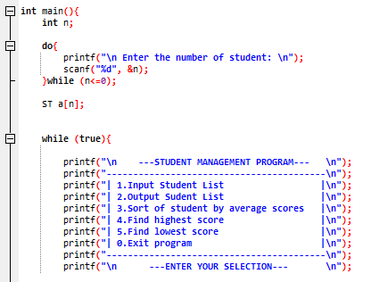

+ printf: Printf messages in the app you do and display it on the screen.

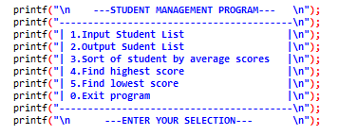

+ Struct: Used to store student object with attributes such as id, name,gender,age,ect.

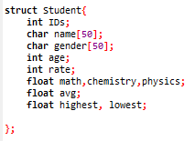

+ getch: Use to stop the screen.

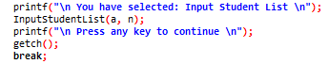

+ Do-while:

* Used for the user to enter the correct condition of ‘n’.
* Used to perform the previous job and check the following condition.

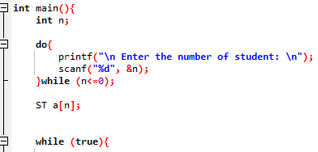

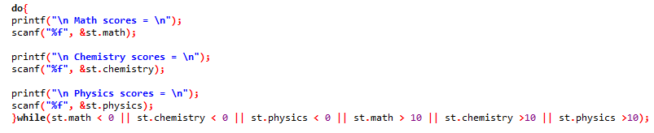

+If-else: Use used to make right and wrong decisions when implementing algorithms.

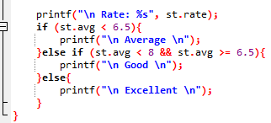

-Struct: Used to declare student objects with properties or program manager.

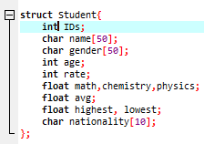

+Switch case: Using switch case statement to create the menu.

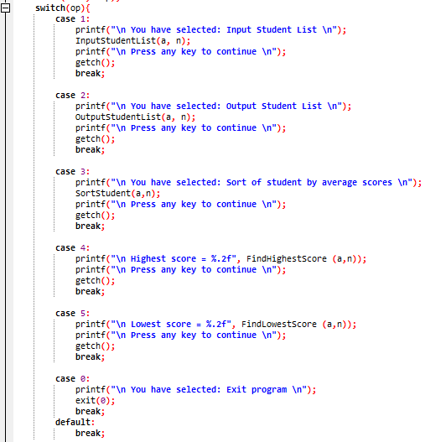

+ for loop: Use ‘int’ for ‘i’ to traverse data from first element to last element.

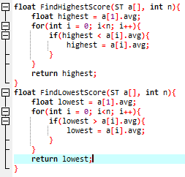

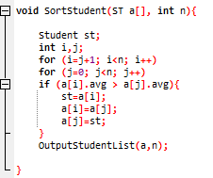

+ void: Return null function.

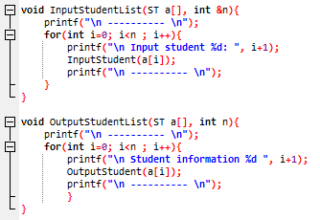

# III/ Progrem results:

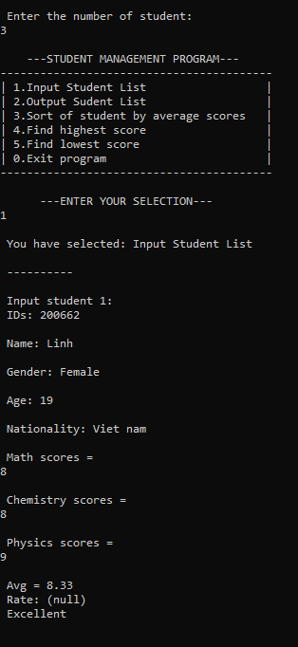

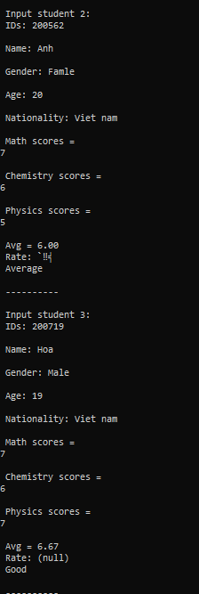

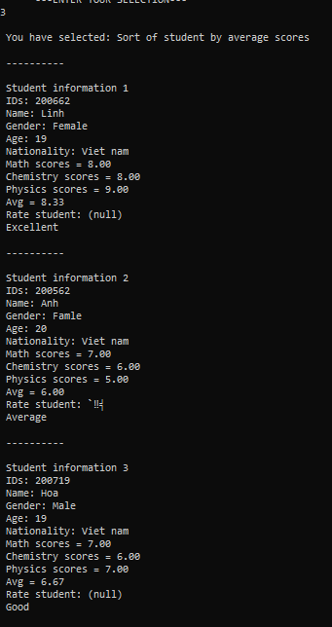

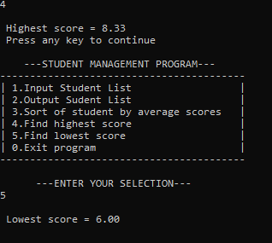

# IV/ Testing:

## IV.1/ Test plan and perform tests:

-First, when I run the program, I will enter the student number as negative to see if it works. If it doesn't work, the program will re-enter .

-Next, the program will display a menu for the user to choose from 0-5.

-Select 1 to enter id, name, age, ....

-I will press any key to continue the program. the following options are similar.

-Select 2 to display the part entered in 1.

-Select 3 to display the average score.

-Select 4 to display the highest grade point average.

-Select 5 to display the lowest grade point average.

-Select 0 to exit the program.

## IV.2/ Show test:

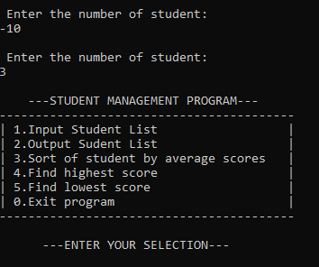





# V/ Evaluation:

I think my program is not very good, need to change some places to be more suitable.

Through creating this student management program I have learned a lot about coding. it helped me improve my background knowledge, understand more about how functions, variables, statements, and loops are used.

In the future, I will write a more complete student management software with many functions based on the designed algorithms.

# Bibliography

(2021, 10 28). Retrieved from learncomputerscienceonline.com: https://www.learncomputerscienceonline.com/procedural-programming/

Cordrey, L. (2021, 10 29). Retrieved from popularask.net: https://popularask.net: https://popularask.net/which-of-the-following-is-a-main-characteristic-of-procedural-programming-language/?fbclid=IwAR1EOdIZqEnRmfwDA15-V1zZHECGGma92dS13gFxfN8_yiPUP5unXvtaX8M